International Convention
An international agreement on a particular subject. They are often drafted by the UN and signed by a majority of countries of the world. The UDHR is an example.
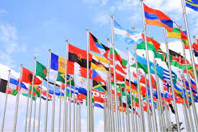

Ratified

To formally consent to and agree to be bound by a treaty, contract or agreement

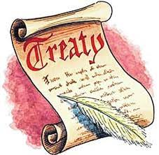
Treaty

A written agreement between nation states which a country is bound to observe. They guide how nations relate to each other.

Bilateral Treaty

Where a treaty exists between Australia and ONE other country

Multilateral Treaty

Where a treaty exists between Australia and two or more countries

Australian Law
If Australia signs an international treaty, it means that we intend to create laws to make sure we meet the expectations of the treaty. In Australia, the Parliament plays an important role in examining treaties and passing legislation (laws).
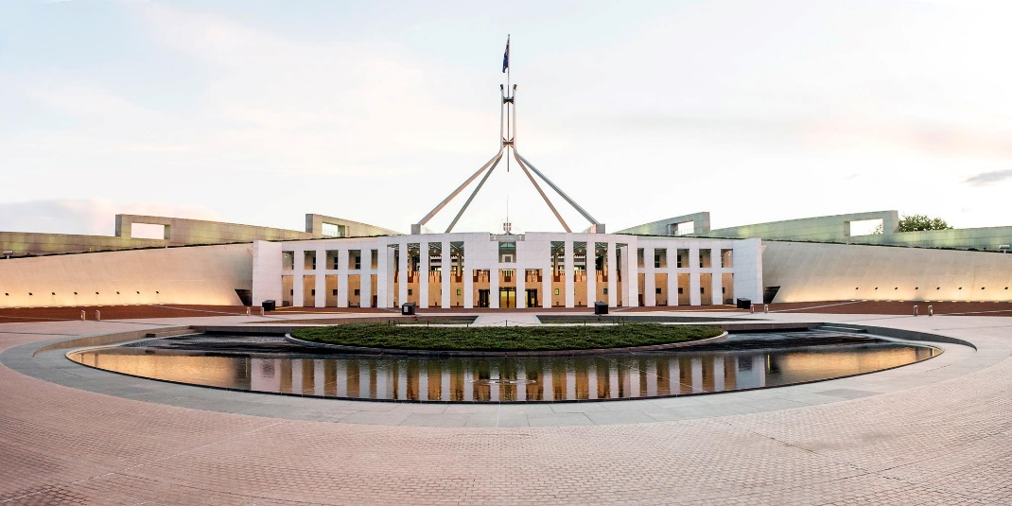

Eliminating Racial Discrimination
The treaty that Australia has signed to eliminate racial discrimination is called the International Convention of All Forms of Racial Discrimination (ICERD).

It means that no one can be discriminated against based on their race.

One example of this is the Commonwealth Racial Discrimination Act 1975.
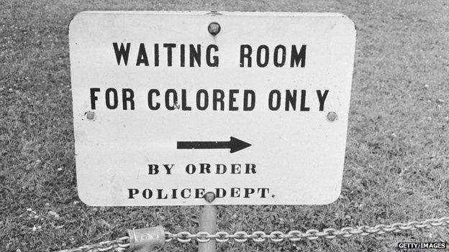
For example, someone can’t advertise a job which states that people of certain nationalities can’t apply for a job.

Protecting the Environment
The treaty that Australia has signed to makes rue that places which are of cultural and natural importance are protected for future generations is called the Convention for the Protection of the World Cultural and Natural Heritage.

One example of this is the World Heritage Properties Conservation Act 1983.

For example, any attempt to destroy a World Heritage Site (such as the Great Barrier Reef) is illegal.
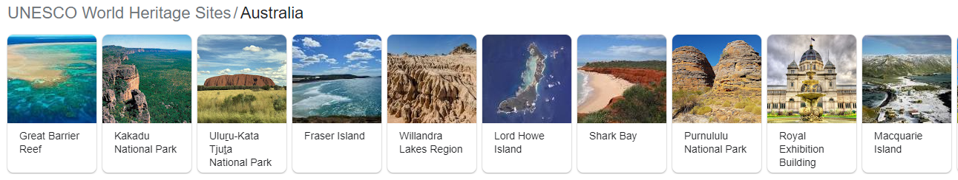

Role of the High Court in International Treaties

The signing of treaties can lead to international disputes that require international courts to resolve them.


International treaties can also lead to domestic disputes (within a country), and the High Court is asked to resolve these.

